Wednesday | June 30, 2021 |  |  |  | Issue 10
PARENTING CULTURE
 | GENDER DEVELOPMENT IN CHILDREN
Welcome!
A note from our founder

------- Anjali Ferguson, PH.D.

Welcome to Parenting Culture; a resource and community promoting an inclusive and culturally responsive space for parenting dialog.

My name is Anjali Gowda Ferguson and I am an Indian American clinical psychologist with parenting, early childhood mental health and trauma-informed care. I recently started my own parenting journey and am continually struck by the lack of culturally responsive parenting resources. While I specialized in parenting well before becoming a parent myself, I often found it hard to resonate with existing interventions. They never seemed to represent my communities and upbringing. Online and Offline spaces can often feel unwelcoming of my cultural experiences and thoughts. It felt like something was missing in the parenting world.

So welcome to Parenting Culture, a culturally inclusive and diverse parenting resource.

Anjali Gowda Ferguson, Ph.D. Clinical Psychologist with specialization in early childhood mental health, trauma, and parenting.
Gender Identity Development in Childhood
A normative developmental process
-------------- Anjali Ferguson, Ph.D. |  | For example, the notions that; “boys are active,” “girls like pink” have no scientific rationale, they were just created based on thought.  Historically, gender diversity was considered a mental health condition.  Modern classification/diagnostic manuals to this day include a pathological condition related to gender identity; HOWEVER, Gender diversity, exploration, development, and fluidity is not pathological.  Age 2: Children start to notice physical differences.  Age 3: Children can label themselves as boy or girl  Age 4: Children have an understanding of their gender identity.  The data shows that children who are gender diverse (i.e. non-conforming or non-matched with their biological sex) know their gender just as clearly as their gender-matched peers. Children who express a gender-diverse identity who feel supported by their family experience lower depression, suicidal ideation, anxiety (www.cdc.org).
Did you know children begin their gender identity development as early as 2 years of age? There is so much we intentionally and unintentionally do as parents to promote and support this process. Gender exploration is a normative process of development that occurs several times throughout our childhood and can continue to occur into adulthood. It is important that as parents we understand these processes and meet every child with love and support through their individual journey.
Gender V’s. Sex:
Sex: the assigned gender of an individual based on physical characteristics at birth
Gender: a social construct of an internal state that is informed by intersections of biology, development, and environment
Gender is a social construct: This means that gender is not based on true biological or scientific differences (sex) but was rather created by society to classify behaviors. Culture and society influence how gender is expressed and how people operate in the world.

Wednesday June 30, 2021
Parenting Culture

Parenting Culture is a team of strong, resilient parents who are all psychologists of color with expertise in children/adolescence.

We each bring our own lens, area of specialty, and personal experiences to the table in efforts to provide holistic and competent resources that capture the diversity in parenting.

----------ARIANA HOET, PH.D.

Dr. Ariana Hoet is a cofounder of Parenting Culture and a pediatric psychologist who works in primary care. Her personal experiences of immigrating from Venezuela as a teenager allows her to bring a bilingual and culturally informed approach to working with families. Her personal goals include raising a bilingual child with love for culture and country, along with understanding privileges and how to actively work on an anti-racist society.

Ariana Hoet, Ph.D. Clinical Psychologist
Picture Caption: To make your document look professionally produced, Word provides header, footer, cover page, and text box designs that complement each other.
LGBTQ Teens Mental Health
-------------- Ariana Hoet, Ph.d.  85% of LGBTQ teens report verbal abuse.  27% report being physically harassed.  13% were physically assaulted while in high school.  58% said they do not report this to school staff because they did not think anyone would help.  64% of those who did report said they were ignored.  This bullying and aggression leads to higher rates of school dropouts or not seeking higher education.  20-40% of homeless teens identified as LGBTQ. Homeless LGBTQ teens are at higher risk for sexual exploitation.  30% LGBTQ teens have experienced a mental health disorder.  ~32% will attempt suicide |  | 58% dijo que no reportan esto al personal de la escuela porque no creían que nadie ayudaría.  64% de los que sí informaron, dijeron que fueron ignorados.  Este acoso y agresión conduce a tasas más altas de deserción escolar o no llegan a la educación universitaria.  20-40% de los adolescentes sin hogar se identifican como LGBTQ  Los adolescentes LGBTQ sin hogar están en mayor riesgo de explotación sexual.  30% de los adolescentes LGBTQ han tenido un trastorno de salud mental  ~ 32% intentará suicidarse
LGBTQ Teens Need Social Support

 |  | LGBTQ teens with more social support reported LESS depression, suicidal thoughts, anxiety, drug use, school avoidance, and violence.  Social support was defined as the teen feeling cared for and loved, esteemed, and a member of a network.  Your behavior towards your kid, peer at school, or colleague at work can make a large difference in their mental health. |  | Los adolescentes LGBTQ sienten más hostilidad y menos apoyo social  Por eso el apoyo social es tan importante para el desarrollo de la salud y la autoestima  El apoyo social se definió en este estudio como el adolescente que se siente cuidado y amado, estimado, y miembro de una red social.  Tu comportamiento hacia tu hij@, compañer@ en la escuela, o colega en el trabajo puede hacer una gran diferencia en su salud mental.
-------------- Ariana Hoet, Ph.D.
LGBTQ teens experience more hostility and less social support.

SO social support is so important for health development and self-esteem
Wednesday June 30, 2021
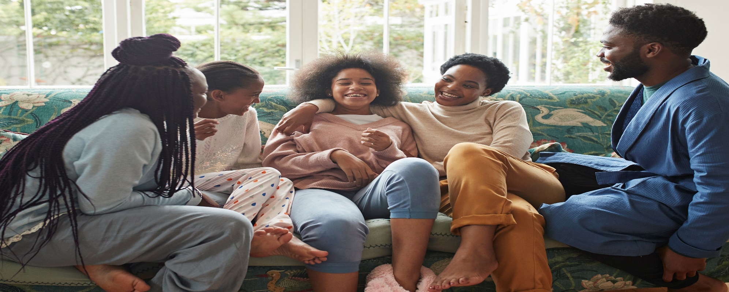
Responding to you Child’s Challenging Questions about Gender/Sex
A Guide:
-------------- Jadig Garcia, Ph.D.  Kids are naturally curious and will often ask questions when they don’t understand something. These questions can catch parents off-guard or make us feel uncomfortable, particularly when the questions are about a taboo or complex topic. Here are some common questions that are asked during early childhood |  |  | Remember kids will learn that they should not talk about something or approach you with their thoughts when you have a negative response to their questions. Kids are naturally curious and they learn by asking questions!  While their questions may make you uncomfortable, here are some general tips to help:
Jadig Garcia, Ph.D. Clinical Psychologist |  | This is also a good time to talk about “private parts” and that no one else should touch their “private parts”  Sample responses:  - Most boys (or most girls) have _______.  - When you get older you may have _____.  2. Questions about family structure:  Examples:  - Everyone has a mommy and a daddy  - Why does _____ not have a daddy/mommy?  - Why does _____ have two mommies/daddies?  - Does everyone have a grandma at their house?  Sample Responses:  - Everyone’s family can look different. Some families have two mommies, some have two daddies, some only have 1 mommy and some only have  grandparents (i.e., give them  examples of how families can  look different).  - Provide books/media that normalize all types of family structures. |  | 3. Comments about gender roles:  Examples:  - Boys don’t cry!  - Boys don’t play with dolls  - Girls can’t play with trucks  - Girls like pink!  - Boys don’t wear dresses  - Boys have short hair  Sample Responses:  - Everyone cries when they feel sad and sometimes when they are angry or excited!  - Boys and girls can play with whatever toys they would like!  - Boys and girls can wear dresses.  - Some girls like pink and some girls dont!  - Boys and girls can have short or long hair.  Generally:  - Ask clarifying questions to know exactly what they are asking you. “What do you mean”, “what do you think”  - Keep your response simple and straight forward  - Be honest :) Its Ok to say “I don’t know” and also keep in mind their age!
Common Questions
And how to respond:
1. Questions about anatomical differences:

Examples:
- Why does daddy/mommy have a _____?
- Will I have _____ when I get bigger?
- I am going to have _____ like daddy when I get bigger!
Response:
Keep responses short and simple! It is a good idea to use correct terms for body parts when explaining physical differences (i.e., vagina, penis).

